MULESOFT ANYPOINT PLATFORM
Assignment-2
Name: Subhapreet Patro
Roll No.: 2211CS010547
Section: I
Q1) Write down the steps to configure the mule application by importing the API from Anypoint Platform.
A)
This process demonstrates how to import a designed and published RAML-based API (from a previous experiment) from Anypoint Exchange into Anypoint Studio, and then create a Mule flow to send a request to the mock endpoint and return a response.
1. Launch Anypoint Studio
- Open Anypoint Studio on your system.
2. Create a New Mule Project
- Go to File → New → Mule Project.
- Enter the Project Name: EmployeeAPIConsumer
- Click Finish.
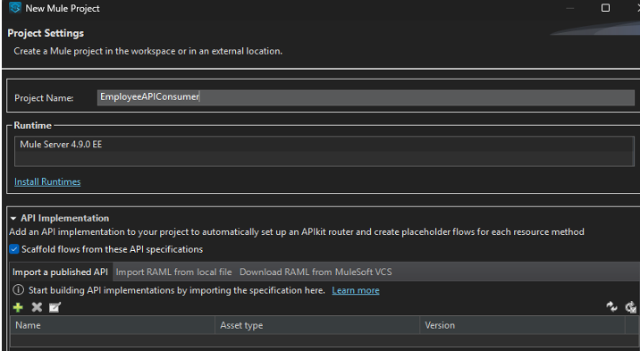
3. Import the Published API
- Click Import a published API.
- Click the green + button as shown in your reference image.
4. Add Anypoint Platform Account
- In the Add Dependencies to Project dialog:
  - Your Anypoint username should be visible in the dropdown.
  - If not, click Add Account and log in with your Anypoint Platform credentials.
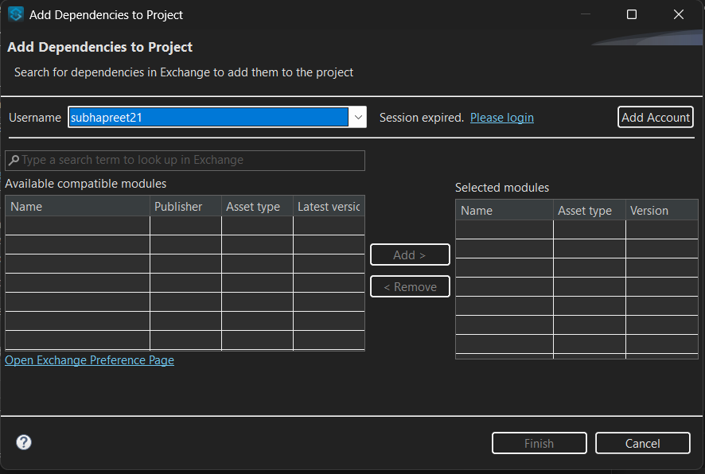
5. Search and Select the API
- In the search bar, type the name of your published API (e.g., Employee API).
- When it appears:
  - Select the API.
  - Click Add > to move it to the Selected modules section.
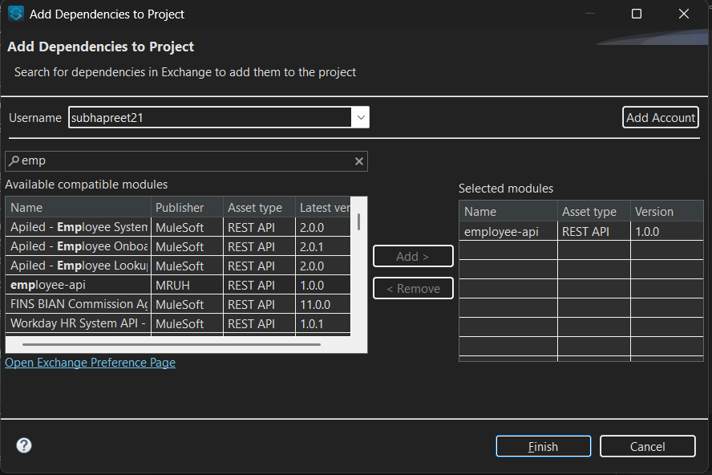
6. Complete the Import
- Click Finish.
- Click Finish again.
7. Project Structure After Import
Your Mule project will now include:
- RAML files under src/main/resources/api
- Scaffolded flow for each method and resource in the RAML
- Pre-built router using APIkit to handle /employee paths
8. Open the Generated Flow
- Open the generated flow file (e.g., employee-api.xml).
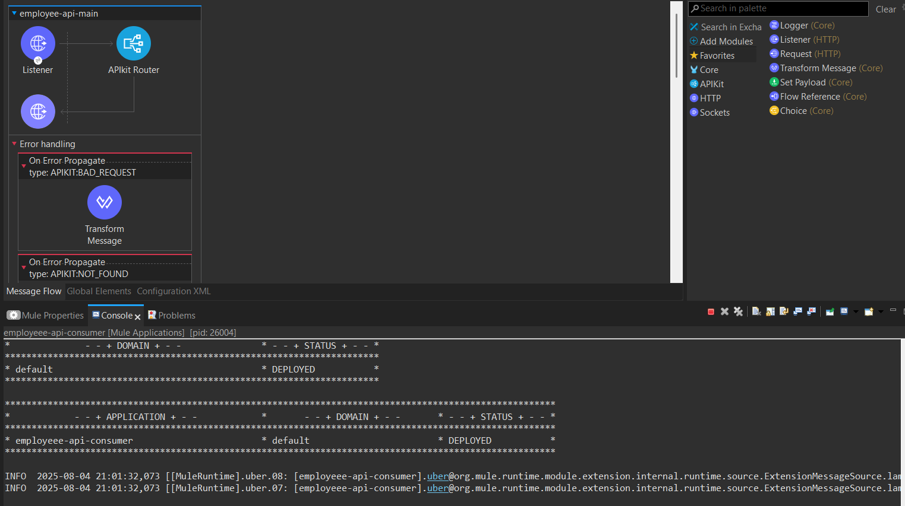
9. Review Auto-Generated Flows
- Inside the file, you’ll find flows like:
  - get:/employee:application/json
- These are based on the methods defined in your RAML specification.
- Do not change anything; simply save the file.
10. Deploy the Application
- Wait until you see the message deployed in the console.
11. Test the Application
- Open a browser and visit:
- http://localhost:8081/api/employee
- You should see the output returned from the mock endpoint.
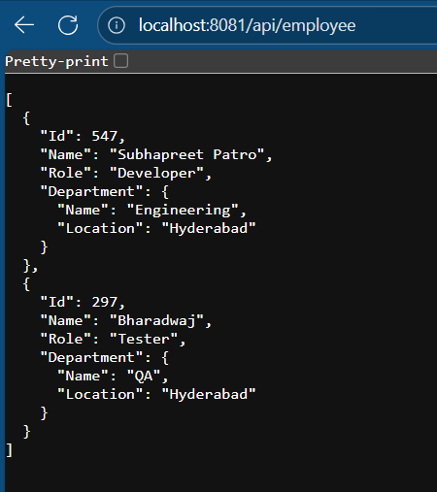

Q2) Explain the concept of Mule Events and illustrate their structure with diagram?
A)
Mule Events
A Mule Event contains the core information processed by the Mule runtime. It travels through the various components of a Mule application according to the configured application logic.
Mule events are immutable, meaning any change to an event results in the creation of a new instance rather than modifying the existing one.
A Mule event is composed of two main parts:
- Mule Message – Contains the message payload and its associated attributes.
- Variables – Metadata used within the flow.
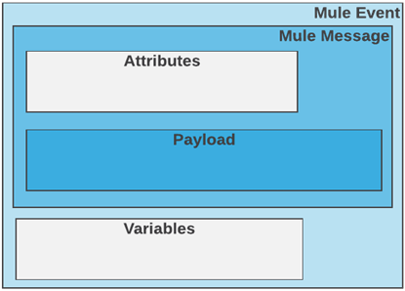
Event Creation
A Mule event is generated by a Mule Event Source (previously called a message source).
Event sources can be:
- Triggers – e.g., Scheduler
- Listeners – e.g., HTTP Listener, On New or Updated File component
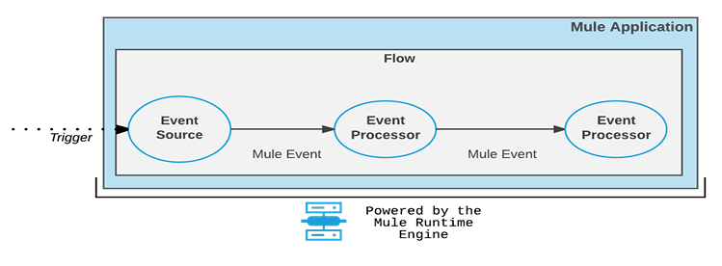
Lifecycle of a Mule Event:
- A trigger reaches the event source.
- The event source produces a Mule event.
- The event travels sequentially through the components of the flow.
- Each component interacts with the Mule event in a predefined way.
If an issue occurs in the event source (for example, an incorrect HTTP listener path), the Mule event is not created. In such cases, connectors log the problem using ERROR, WARN, or INFO messages.
Purpose and Importance
A Mule event contains all the essential information required for execution by the Mule runtime.
- Triggered by a message source such as an HTTP request or listener.
- Critical for smooth flow execution in API creation.
- Immutable: even a small change creates a new instance.
- Contains all relevant information (attributes, payload, variables) passed from one processor to the next.
While the event source initiates execution, the event processor is more critical for successful flow execution.
Structure of a Mule Event
A Mule event consists of:
1. Mule Message
The Mule Message has two parts:
- Attributes – Metadata such as headers and properties. For HTTP requests, this includes method type, host, and port. Attributes remain available throughout the flow unless explicitly updated.
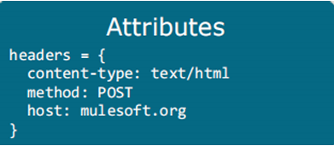
- Payload – The main body of the message, containing the actual data being processed (e.g., JSON, XML). This is set or replaced using the Set Payload component. The payload persists until replaced by another Set Payload operation.
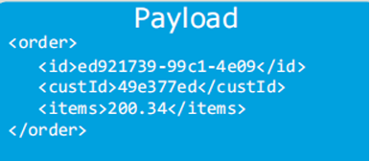
2. Variables
Variables store temporary, per-event values for use within a specific flow.
- Created using the Set Variable component.
- Can store any supported data type (objects, numbers, strings, etc.).
- Accessible only within the flow where they are created.
- Separate from the Mule Message because they are intended for temporary use and are replaced whenever a new variable is set.

Q3) What is debugging? Write the steps to debug a mule application
A)
What is debugging?
Debugging is the process of running your application under a special mode (the debugger) so you can pause execution, inspect the runtime state (payload, attributes, variables, connector responses, etc.), find the cause of errors or unexpected behavior, fix the issue, and then re-run to verify the fix. In Anypoint tooling you debug Mule apps with an embedded debugger that lets you add breakpoints, step through flows, inspect events, and hot-deploy fixes.
Steps to debug a Mule application (detailed — from the PDF)
- Set breakpoints where you want execution to pause.
  - Breakpoints can be added on lines in a configuration XML file (e.g., a <flow-ref> or component line) or on components in the canvas UI. Use breakpoints to inspect the Mule event (payload, attributes, variables) at key points.
- Open the Run & Debug panel.
  - In Anypoint Code Builder / Anypoint Studio use the Run & Debug view to start and control a debug session. Keyboard shortcuts: Mac: Cmd+Shift+D, Windows: Ctrl+Shift+D.
- Run the application in debug mode.
  - Click Start Debugging (F5) (or choose Debug Mule Application). If the Start Debugging icon is not present, select the Mule XML Debugger from the Run & Debug options to initiate the session. When the runtime deploys successfully you’ll see a DEPLOYED message in the output/terminal.
- Trigger the flow you want to inspect.
  - Start an event that reaches an event source: call the HTTP Listener URL, fire the Scheduler, or drop a file depending on your flow. When execution reaches a breakpoint the app will pause.
- Inspect the paused state and use the debug toolbar.
  - While paused you can view the current Mule event (payload and attributes) and any variables, evaluate expressions, and inspect connector/component outputs. Use the debug toolbar to step over, step into, resume/continue, or stop.
- Fix the issue and hot-deploy if needed.
  - After identifying the problem, make code/configuration fixes. Use the hot-deploy capability to redeploy the running instance without fully restarting the runtime, then re-execute your flow to confirm the fix. Repeat until all issues are resolved.
- Stop the debug session.
  - When finished, stop the debugger (terminate the debug session) to return to normal run mode.
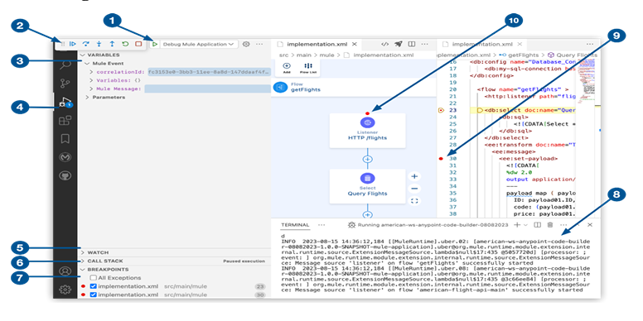
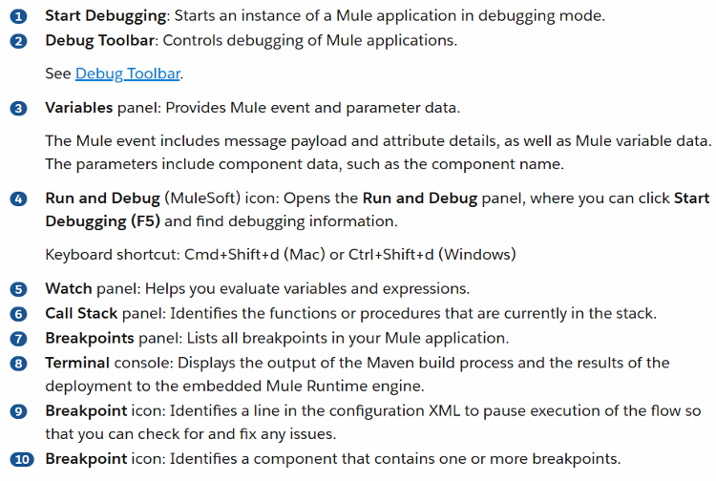
How to add breakpoints (two ways)
A. Add a breakpoint in a configuration XML file
- Open the XML config (e.g., my-project.xml) in the editor.
- Open the Run & Debug panel.
- Click the line number of the component where you want a breakpoint (for example the <flow-ref> line) or press F9 to toggle a breakpoint on the current line.
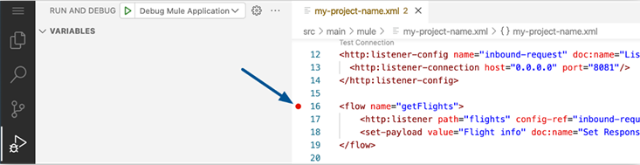
- Add breakpoints on other lines/components you want to inspect (the PDF example suggests adding breakpoints on <db:select> and <set-variable>). All breakpoints appear in the Breakpoints panel.
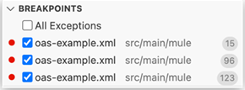
B. Add a breakpoint from the Canvas UI
- Open your configuration in the canvas view.
- Right-click the component you want to pause on and choose Add Breakpoint.
- A breakpoint icon appears on that component and in the XML config.
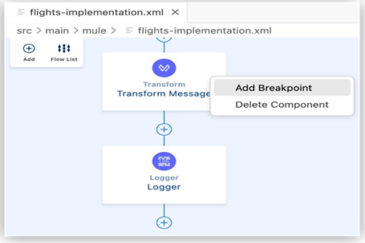
Running the app and reading debug output
- Start debugging via the Run & Debug view (Start Debugging / F5).
- On successful deploy you should see a DEPLOYED status message in the terminal/output and the runtime status indicator (the status bar) may change color to show the app is running under the debugger. A terminal window opens to show runtime logs.
Using the debug toolbar
- While execution is paused you can:
  - Inspect Mule Event (payload + attributes) and variables.
  - Step through components (Step Into / Step Over / Step Out).
  - Evaluate DataWeave expressions or variable values.
  - Resume execution to continue until the next breakpoint.
- After making fixes, use hot-deploy to apply changes to the running app and re-test flows.
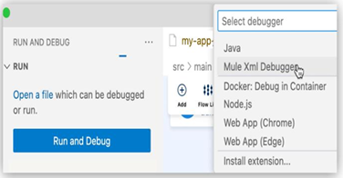
When the application deploys successfully, you see a DEPLOYED log message in the output panel:
********************************************************************* * - - + DOMAIN + - - * - - + STATUS + - - * ********************************************************************* * default * DEPLOYED * *********************************************************************
